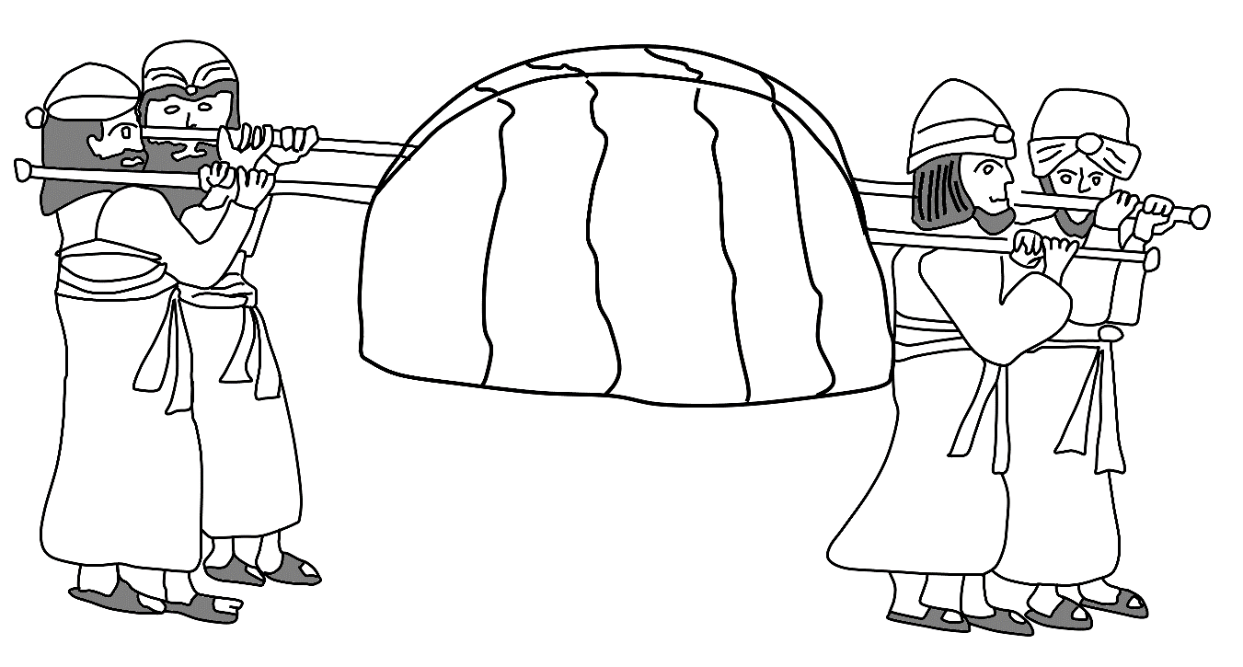

Tomado de: https://auntiesbiblelessons.wordpress.com/2011/08/17/crossing-the-jordan-river/

Desierto
Tierra prometida

