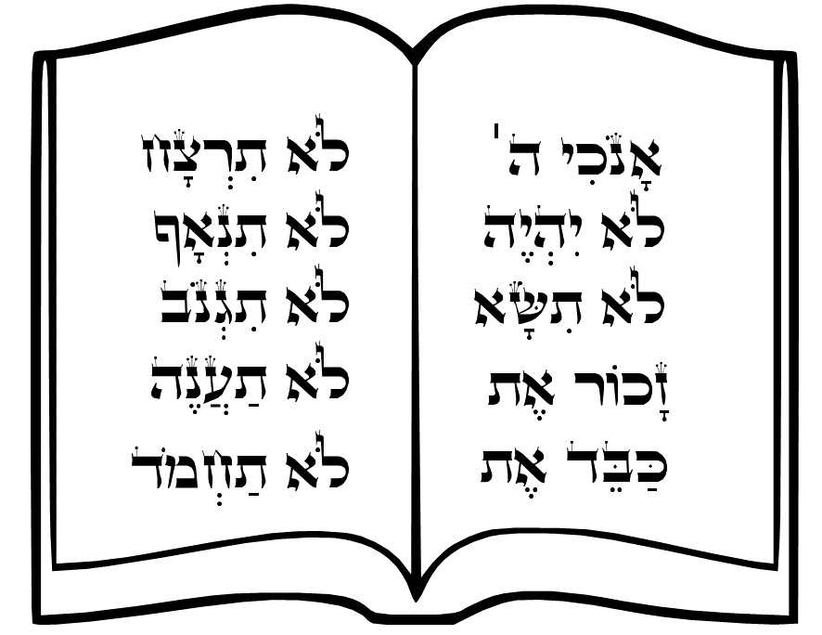

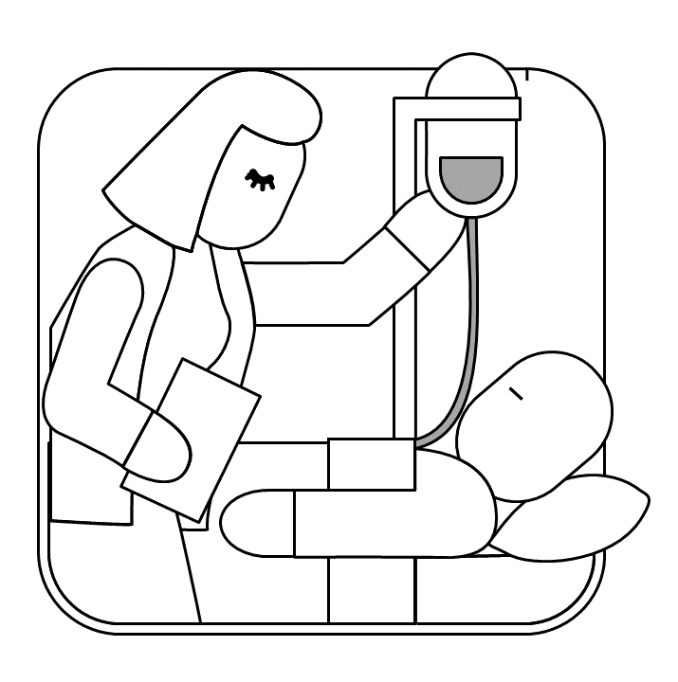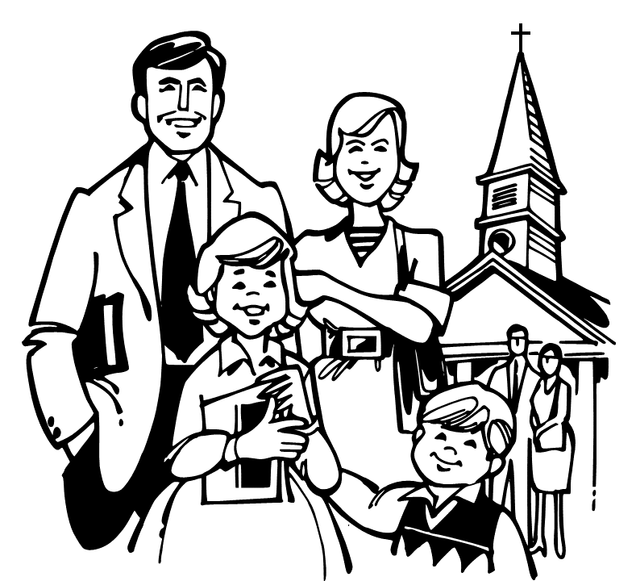

Los dibujos fueron tomados de:
https://openclipart.org/detail/148945/praying-girl
https://openclipart.org/detail/284253/just-married
https://openclipart.org/detail/288026/nurse-with-iv
https://openclipart.org/detail/253535/going-to-church
https://openclipart.org/detail/3142/children-sharing-a-ball
https://openclipart.org/detail/168268/family-1
https://openclipart.org/detail/214517/bible-and-bookmark
https://openclipart.org/detail/169641/10-commandments
El texto en el dibujo de la Biblia corresponde a los 10 mandamientos en hebreo.

